**Assignment 12.2:**

Given a list of strings - List[String] (“alpha”, “gamma”, “omega”, “zeta”, “beta”)

* find count of all strings with length 4.

**Output:**

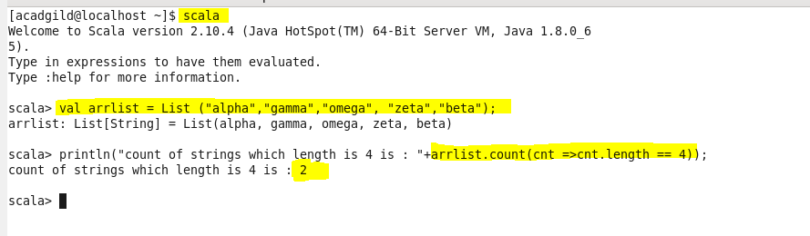

* convert the list of string to a list of integers, where each string is mapped to its corresponding length

**output:**



* find count of all strings which contain alphabet ‘m’

**output:**

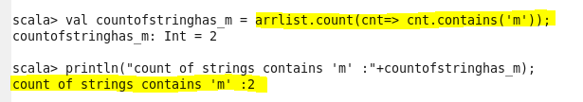

* find the count of all strings which start with the alphabet ‘a’

